**A CRM Application to Manage the Services offered by an Institution**

**TEAM MEMBERS:**

**ALIVE SANTHOSH.D**

**AADIL AASIF.N**

**ARJUN.S**

**YUVANKISHORE.D**

**Email id: - alivesanthosh7@gmail.com**

**Project Overview:**

The objective of this project is to implement a Salesforce-based CRM solution to manage the courses offered by an institution, including course registration, tracking student progress, managing interactions, and providing insights for improved decision-making. This CRM system will streamline communication between the institution and students, enhance the course management lifecycle, and provide a centralized platform for managing all aspects of course offerings from initial inquiry to course completion.

# Objectives:-

1. **Course Management:**
   * Create and manage a catalog of courses offered by the institution, including details such as course descriptions, instructors, schedules, and pricing.
   * Track course enrollments, cancellations, and waiting lists in real-time. o Automate course-related tasks, such as confirmations, reminders, and follow-ups.
2. **Student Management:**
   * Maintain a comprehensive student database, including personal information, academic history, and course enrollment details. o Track student engagement and performance across various courses. o Provide personalized student experiences with relevant course recommendations, notifications, and progress tracking.
3. **Marketing and Communication:**
   * Use Salesforce marketing tools to automate lead generation and follow-ups for prospective students.
   * Segment students based on their interests, course history, or behavior to deliver targeted communications and promotions. o Enable automated email campaigns, SMS notifications, and in-app messaging for timely updates on course registration, deadlines, and announcements.
4. **Analytics and Reporting:**
   * Generate detailed reports on course performance, student satisfaction, and enrollment trends. o Provide actionable insights into which courses are most popular, student retention rates, and areas for potential course improvements. o Create dashboards for administrators, course managers, and instructors to monitor key metrics.
5. **Integration with Other Systems:**
   * Integrate Salesforce with external systems such as Learning Management Systems (LMS), payment processors, and institutional HR systems for seamless data sharing. o Enable real-time synchronization of course information, student performance, and billing details across platforms.

# Salesforce Key Features and Concepts Utilized:-

**1. Create Objects from Spreadsheet:**

In Salesforce, you can create **custom objects** to store data that's unique to your organization's needs. If you have a **spreadsheet** with information you'd like to import into Salesforce and create corresponding **custom objects** (e.g., Course, Student, Enrollment), you can use Salesforce's **Data Import Wizard** or **Data Loader** for data import. However, first, you need to define the **custom objects** in Salesforce.

**2.Create a ScreenFlow:**

Creating a **Screen Flow** in Salesforce allows you to create an interactive, user-friendly process for gathering information, guiding users through a series of screens, and updating records.

**3.Create Users:**

Creating users in Salesforce is an essential step to grant access to the platform. Users can be granted different levels of permissions and can access specific data or features based on their profile and role.

**4. Create an Approval Process:**

An **Approval Process** in Salesforce automates the approval of records in your organization, such as documents, opportunities, or other types of records that need managerial review and approval before they proceed to the next stage.

**5.Create a Record Triggered Flow:**

A **Record-Triggered Flow** in Salesforce is a type of **Flow** that automatically runs when a record is created, updated, or deleted. It helps automate processes such as updating related records, sending notifications, or taking any necessary actions based on the changes made to a record.

**6.Create a lightning app page:**

Creating a **Lightning App Page** in Salesforce allows you to create a custom user interface that can include different components, such as records, reports, and custom Lightning components. You can tailor the page layout and content to suit the needs of different users in your organization. Lightning App Pages can be used in the Salesforce app or as custom pages for your Lightning experience.

# Detailed Steps to Solution Design

## Create object

1. Go to your object manager and and click on create object from spreadsheet
2. Click on the link to get the spreadsheet, [Course.](https://docs.google.com/spreadsheets/d/1RD3chCZ1BWZxAKQxtntArr27K1iQxiNobeTA1iWe4Dc/edit#gid=613505717)
3. After downloading, upload the file, map the fields and upload to create an object

4.Use the following sheets for remaining objects.

* 1. [Consultant](https://docs.google.com/spreadsheets/d/12q_u-63PZ3MTCgJS1voKsvTL_jVIjW4kyI_9shgB97s/edit#gid=198933105)
  2. [Student](https://docs.google.com/spreadsheets/d/1QbkK_l1K5x9aBN8LXrEZfYJ0qMMLU-5NTi5O3_cCe1Q/edit#gid=1705718850)
  3. [Appointment](https://docs.google.com/spreadsheets/d/1Wvk7nWFXR7xn56F8kr1WQCYs5_x6_CUZsFiZtEpVufY/edit#gid=1793530912)

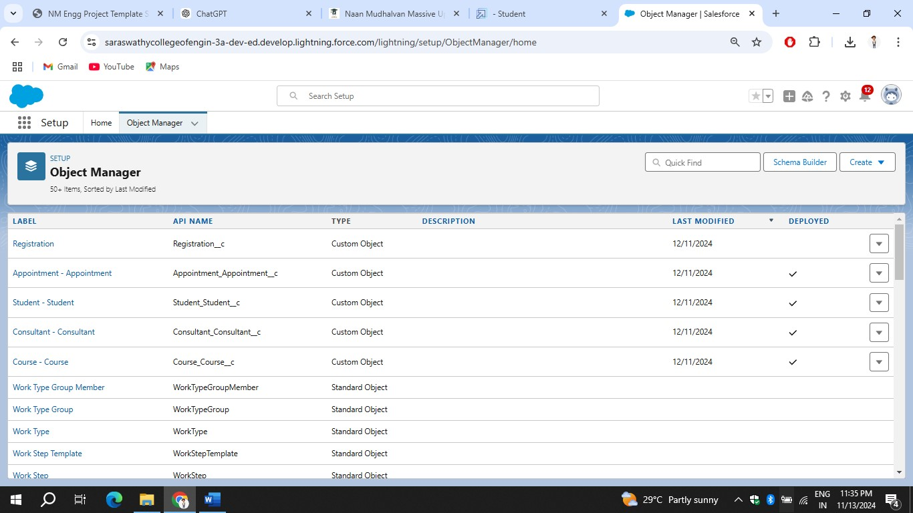

## Create a Lightning App

1. Go to Setup, search for the App Manager in quick find
2. Click on New Lightning App
3. Give app name as “EduConsultPro”, click Next, Next, Next
4. Add Home, Students, Courses, Consultants, Appointments, Registrations, and Cases from the Available Items to Selected Items.

5.Add “System Administrator” profile from Available Profiles to Selected Profiles, click Save & Finish.

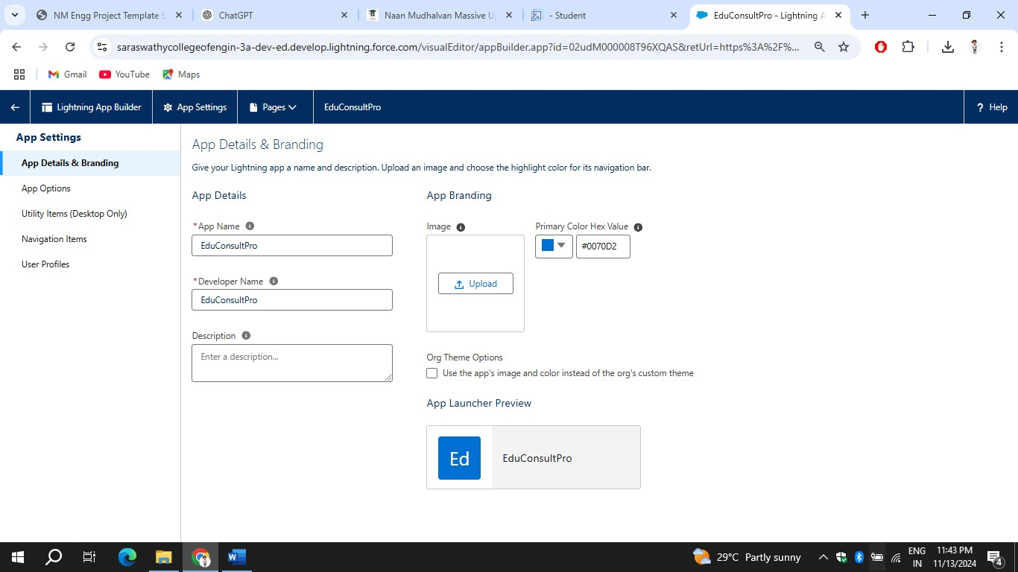

**Create a ScreenFlow for Student Admission Application process.**

## 1.Add Screen Element

1.From Setup, enter Flow Builder in quick find, select new flow --> ScreenFlow.

2.Add a Screen element.

3.In the Screen Properties pane, for Label, enter “Student Info”.

4.Click on Fields, click on the record variable input and create a new Resource(StudentRecordRes) to display all the fields which are in the student object. Drag all the fields which are needed to add on the screen inorder to collect the student information.

**2. Create Student Record using Create Element:**

1. Add a Create element after Student Info Screen Element, Label it as “Create Student Record.”
2. Select “one” under How many records to Create, and select “use all values from a record” under How to Set the record fields.
3. Select the record variable resource(StudentRecordRes) which we have created in the Student Info screen element, under Create a record from these values.

**3.Add Screen Element:**

1. Add a Screen Element after Create Student Record Element and label it as Course Screen.
2. Add a picklist component from the left side panel label it as “Select Course”, under choices type “IELTS” and enter. This creates a variable with the name IELTS.
3. Repeat the same for GRE, GMAT, Duolingo, TOEFL.

**4.Add Decision Element**

1. Add a Decision Element after Select Course Screen Element, label it as Selecting Course.
2. Under outcome label it as “Selected IELTS” and write the condition such as below:

Resource : Select_Course (Screen Component from Select Course Screen

Element)

Operator : Equals

Value : IELTS (Choice Variable from Select Course Screen Element)

1. Click on the “+” icon and Repeat step 2 for other options mentioned as below:
   1. GRE
   2. GMAT
   3. DuoLingo
   4. TOEFL 4. Click Done.

**4.Add GET Record Element**

1. Add a GET Record Element after Decision Element, under the IELTS path and label it as “Get IELTS Rec”.
2. Select Object : Course

Condition Requirement : All Conditions are Met(AND)

1. Field : Course Name

Operator : Equals

Value : {!Select_Course

3.Repeat the steps 1 & 2 for the GRE, GMAT, TOEFL, DuoLingo paths.

## 5.Create Registration Record using Create Records Element

1. Add a Create element after the Get IELTS Rec element and label it as “Create IELTS Registration Rec”.
2. Select “one” under How many records to Create, and select “Use separate resources, and literal values” under How to Set the record fields.
3. Select Object : Registration
   1. Field : Course_Name__c

Value : {!Get_IELTS_Rec.Id}

* 1. Field : Student_Name__c

Value : {!StudentRecordRes.Id}

4.Repeat the steps 1 & 2 for the GRE, GMAT, TOEFL, DuoLingo paths.

## 6.Create Email Text Template Variables for email body and subject

1. Click on the toggle toolbox on the left corner, click “New Resource”, then select “Text Template” as Resource Type.
2. Give the API name as “StuRegistrationEmailTextTempBody”, select “view as plain text” and paste the below text in body.
3. Click Done.

1. Repeat steps 1 & 2 to create an email text template for the email subject, label it as “StuRegistrationEmailTextTempSub”, write a text message in the body and save it.

**7.Add an Action Element**

1. Add an Action Element after all the Decision paths, label it as “Send Email to Student”.
2. Under “Set input values for selected action”, include body, Recipient Address List and Subject.
3. For input Body : {!StuRegistrationEmailTextTempBody}, Recipient Address List : {!StudentRecordRes.Email__c}, Subject : {!StuRegistrationEmailTextTempSub}.

**8.Add Screen Element**

1. Add a Screen Element after the Send Email to Student Action Element, label it as Success Screen.
2. From the left side panel search for the Display text component and drag it to the main panel, label it as “SuccessMessage”.
3. Paste the below in the Resource picker box.
4. Click Done.

5.Save the flow and name it as “EduConsultPro Student Flow”. Your flow will look as shown below:

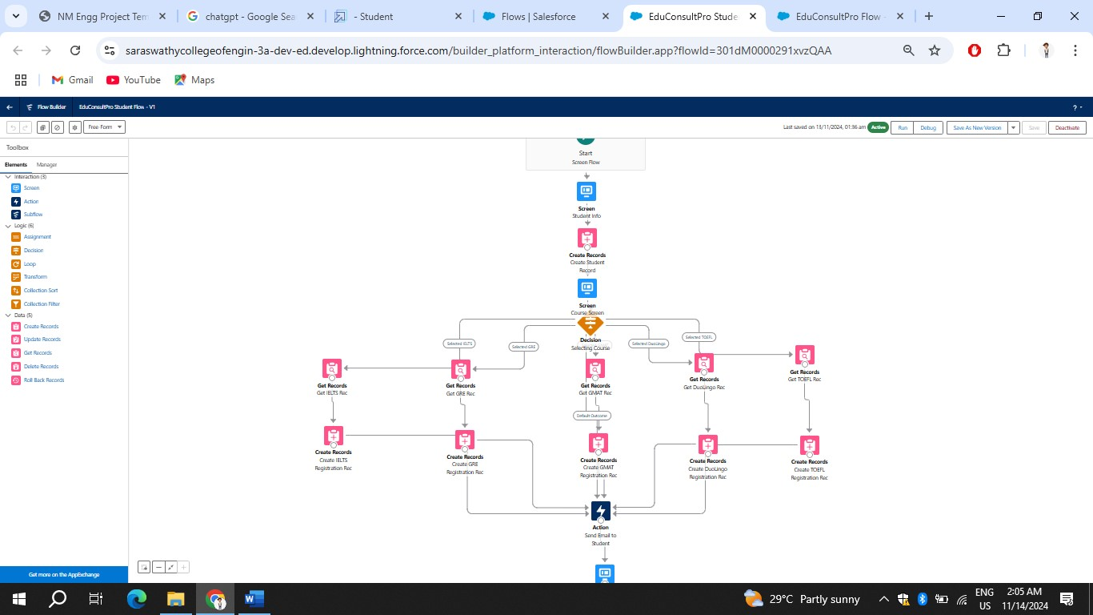

## Create Users

**1.User:**

1. Go to Setup --> Administration --> Users --> New User
2. LastName : Consultant
3. License : Salesforce Platform
4. Profile : Standard Platform User 5. Fill all the mandatory fields & Save.

**2.Configure the User Settings**

1. Go to Setup --> Administration --> Users --> click Edit next to your name
2. Scroll down to bottom, under Approver Settings, Select “Consultant” the Manager Field.
3. Click Save.

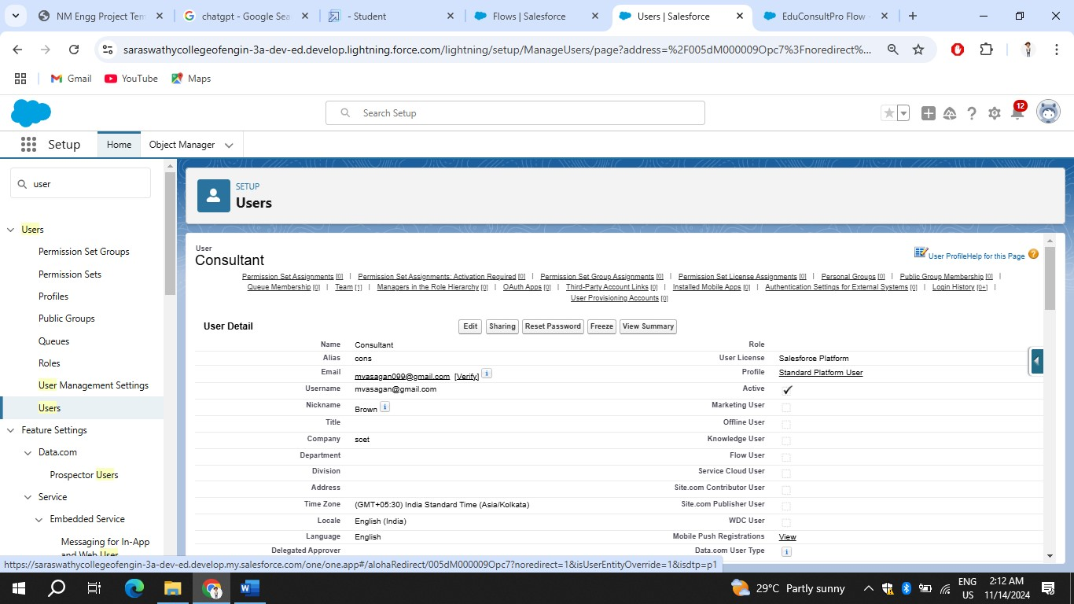

**Create an Approval Process for Property Object:**

**1. Create an Email Template**

1. From Setup, enter Templates in the Quick Find box, and then select Lightning Email Templates, toggle on.

1. go to app launcher, search for “Email Templates”, Create a new folder with the desired name.
2. Then create a new email template, select the folder which we have created in the previous steps, enter the below text in the HTML Value and Save it as "Submission Template".

4.Create two more Email templates for Approval and Rejection of Request similar to the previous one.

**2.Create an Approval Process**

1. From Setup, enter Approval in the Quick Find box, and then select Approval Processes.
2. In Manage Approval Processes For, select Appointment.
3. Click Create New Approval Process --> Use Jump Start Wizard.
4. Configure the approval process.
5. Process Name - Appointment Approval, Under Select Approver, Select Manager for the option : “Automatically assign an approver using a standard or custom hierarchy field.”
6. Click next and “Next Automated Approver Determined By” --> Select Manager.
7. From Record Editability Properties --> Click on Administrators OR the currently assigned approver can edit records during the approval process.
8. Save the approval process.
9. Click View Approval Process Detail Page.
10. Under Initial Submission Actions, click Add New --> Field Update, and configure it with these values.

11.click Add New --> Email Alert, and configure it with these values.

Description : Submission Email Alert

Unique Name : Auto Populates

Email Template : Submission Template

Recipient Type : Select your Name

12.Repeat the Steps 10 - 11 for Final Approval and Final Rejection actions.

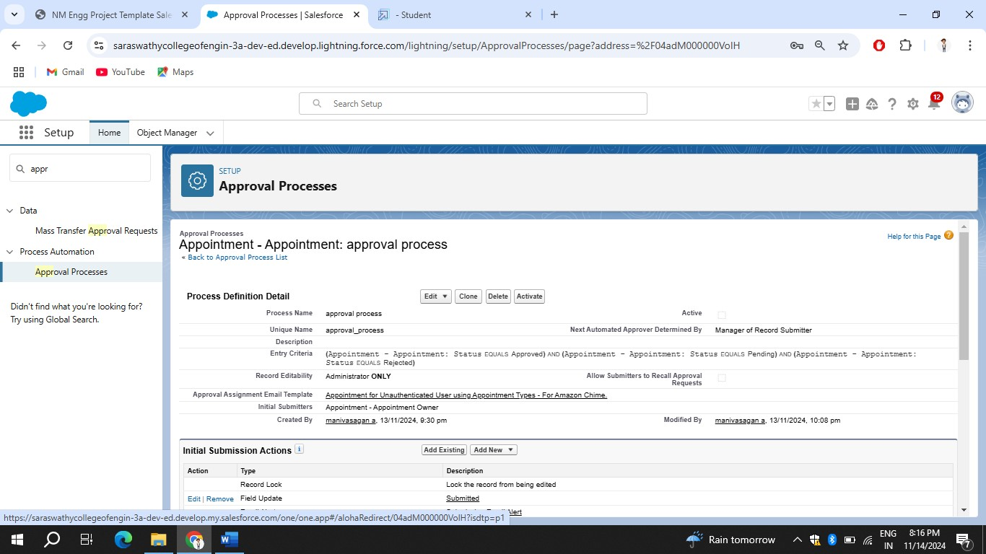

**Create a Record Triggered Flow**

**1.Configure the Start Element:**

1. From Setup, enter Flows in the Quick Find box, then select Flows.
2. Click New Flow.
3. Select Record-Triggered Flow.
4. Click Create. The Configure Start window opens.
5. For Object, select Appointment.
6. For Trigger the Flow When, select A record is created. The flow will look like this:

**2. Add an Action Element**

1. Add an Action element after the Start Element and Select the Submit for approval action, label it as “Approval SubFlow”.
2. Set the RecordId to “{!$Record.Id}”.

1. Save the Flow, label it as "EduConsultPro Approval Flow and Click on Activate.

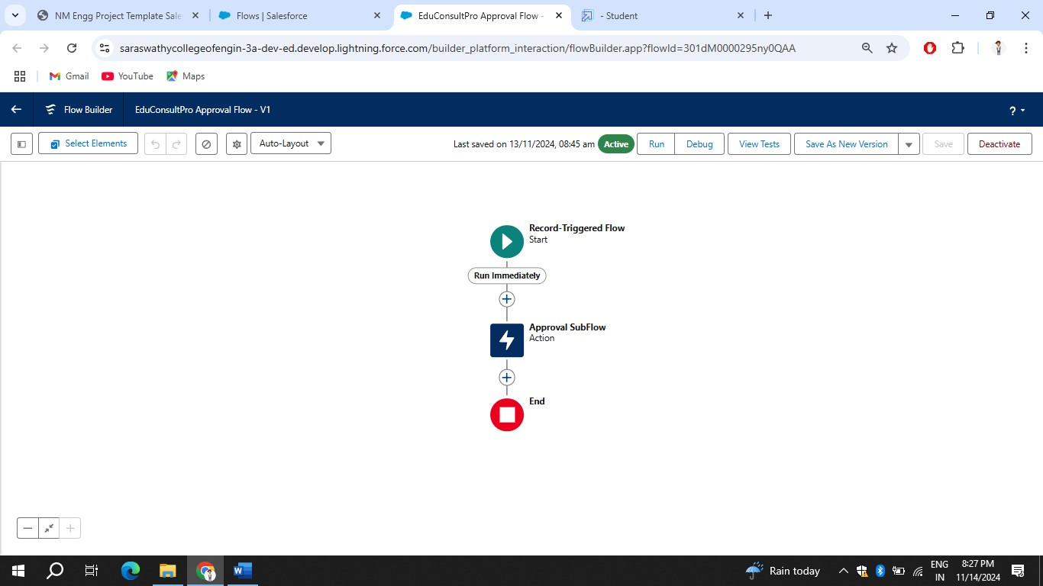

**Create a ScreenFlow for Existing Student to Book an Appointment**

**1. Add Screen Element:**

1. From Setup, enter Flow Builder in quick find, select new flow ?

ScreenFlow.

1. Add a Screen element.
2. In the Screen Properties pane, for Label, enter “Get Student Info”.
3. Add two Text components from the left side panel. Give the Label’s as follows:

1st Text Component Label : Enter Student Name 2nd Text Component Label : Enter Student Email

1. Click on Done.

## 2.Add GET Record Element

1. Add a GET Record Element after Decision Element, under the IELTS path and label it as “Get Rec”.
2. Select Object : Student

Condition Requirement : All Conditions are Met(AND)

1. Field : Student Name

Operator : Equals

Value : {!Enter_Student_Name}

1. Field : Email__c

Operator : Equals

Value : {!Enter_Student_Email}

## 3.Add Screen Element

1. From Setup, enter Flow Builder in quick find, select new flow ? ScreenFlow.
2. Add a Screen element.
3. In the Screen Properties pane, for Label, enter “Display Student Details”.
4. Add Display Text components from the left side panel. Give the API name as “Display_details”, under Resource picker add the below text: Name : {!Get_Rec.Name},

First Name : {!Get_Rec.First_Name__c},

Last Name : {!Get_Rec.Last_Name__c},

Email : {!Get_Rec.Email__c},

Phone : {!Get_Rec.Phone__c},

Gender : {!Get_Rec.Gender__c},

City : {!Get_Rec.City__c},

Address : {!Get_Rec.Address__c},

1. Add a radio button component from the left side panel, label : How may I help you??
2. Click on Add Choice ? type “Book an Appointment” in the input field ? click Create Book an Appointment choice.
3. Repeat step 6 and create an “Immigration Case” choice resource.

## 4.Add Decision Element

1. Add a Decision Element after Select Display Student Details Element, label it as “Appointment or Case”.
2. Under outcome label it as “Appointment” and write the condition such as below:

Resource : {!How_may_I_Help_you}

Operator : Equals

Value : {!Book_an_Appointment}

1. Click on the “+” icon and Repeat step 2 for Case options mentioned.

## 5.Add Screen Element

1. Add a Screen element after the Decision Element and label it as

“Appointment Booking Screen".

1. Click on Fields, click on the record variable input and create a new Resource (AppointmentRecordRes) to display all the fields which are in the Appointment object.
2. Drag all the fields which are needed to add on the screen inorder to collect the student information.
3. Click on Done.

## 6.Add GET Record Element

1. Add a GET Record Element after Decision Element, under the Appointment path and label it as “Get Consultant Rec”.
2. Select Object : Consultant

Condition Requirement : All Conditions are Met(AND)

a. Field : Name

Operator : Equals

Value : {!AppointmentRecordRes.Consultant_Name__c}

## 7.Create Appointment Record using Create Records Element

1. Add a Create element after the Get Consultant Rec element and label it as “Create Appointment”.
2. Select “one” under How many records to Create, and select “Use separate resources, and literal values” under How to Set the record fields.
3. Select Object : Appointment

a. Field : Appointment_DateTime__c

Value : {!AppointmentRecordRes.Appointment_DateTime__c} b. Field : Consultant__c Value : {!Get_Consultant_Rec.Id} c. Field : Notes__c

Value : {!AppointmentRecordRes.Notes__c} d. Field : PurposeTopic__c

Value : {!AppointmentRecordRes.PurposeTopic__c} e. Field : Student_Name__c

Value : {!Get_Rec.Id}

## 8.Add Screen Element

1. Add a Screen Element after the Send Email to Student Action Element, label it as “Confirmation Screen”.
2. From the left side panel search for the Display text component and drag it to the main panel, label it as “Appointment_Confirmation”.
3. Paste the below in the Resource picker box.

Consultant Name : {!Get_Consultant_Rec.Name},

Date & Time : {!AppointmentRecordRes.Appointment_DateTime__c},

Notes : {!AppointmentRecordRes.Notes__c},

4.Click Done.

## 9.Add an SubFlow Element

1. Add a subflow element after the Start Element and search and Select for

“Create a Case”, label it as “Create Student Case”.

1. Save the flow and label it as “EduConsultantPro Existing Student Flow”.

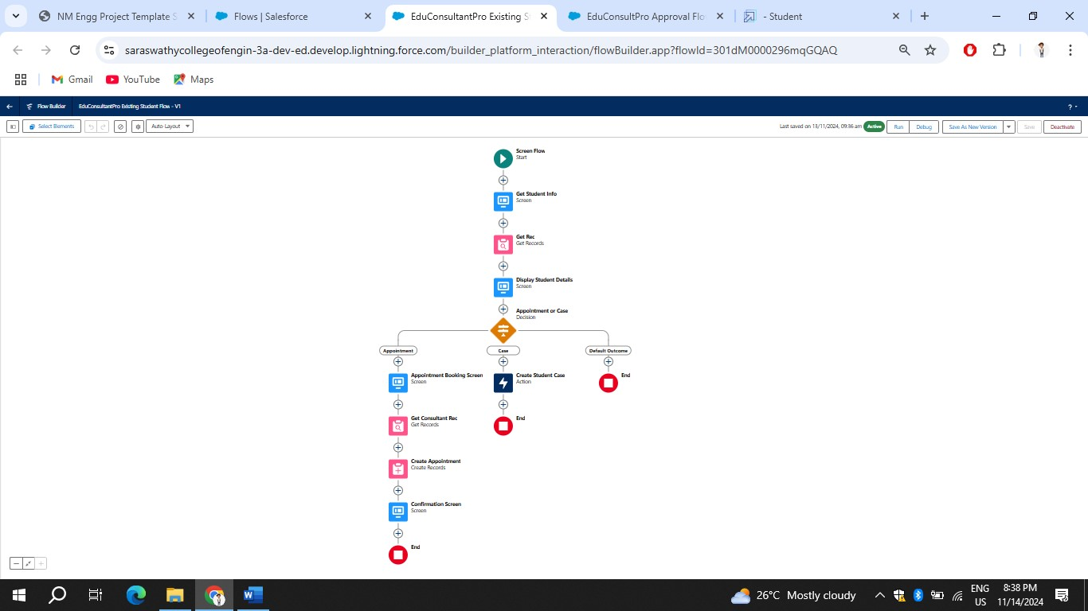

**Create a ScreenFlow to Combine all the flows at one place**

## 1.Add Screen Element

1. Add a Screen Element and label it as Welcome Screen.
2. From the left side panel search for the Display text component and drag it to the main panel, label it as “SuccessMessage”.
3. Paste the below in the Resource picker box.

“Welcome to EduConsultantPro

*your premier destination for education and immigration solutions!*

At EduConsultantPro, we understand that embarking on educational or immigration journeys can be both exhilarating and daunting. That's why we're here to guide you every step of the way with expertise, dedication, and personalized support.

Whether you're seeking to pursue your academic dreams abroad, navigate the complexities of immigration processes, or enhance your professional skills through international opportunities, EduConsultantPro is your trusted partner.

Our team of seasoned consultants is committed to understanding your unique aspirations and crafting tailored strategies to help you achieve your goals efficiently and effectively. From selecting the right educational institution to navigating visa procedures, our comprehensive services cover all aspects of your journey.

At EduConsultantPro, we believe in fostering inclusive communities and unlocking the full potential of every individual. With our unwavering commitment to excellence and integrity, we strive to make your experience with us seamless and rewarding.

Welcome to EduConsultantPro – where your aspirations meet our expertise, and together, we pave the path to success. Let's embark on this transformative journey together!”

4.Click Done.

## 2.Add Screen Element

1. Add a Screen Element after the Welcome Screen Element, label it as

“Existing or New Student Confirmation Screen”.

1. Add a radio button component from the left side panel, label : Are you a Existing Student
2. Click on Add Choice --> type “Yes” in the input field --> click Create Yes choice.
3. Repeat step 6 and create an “No” choice resource.

5.Click Done.

## 3.Add Decision Element

1. Add a Decision Element after Existing or New Student Confirmation Screen Element, label it as “Decision 1”.
2. Under outcome label it as “If Existing Student” and write the condition such as below:

Resource : {!Are_you_a_Existing_Student}

Operator : Equals

Value : {!Yes}

1. Click on the “+” icon and Repeat step 2 for No options mentioned.

## 4.Add an SubFlow Element

1. Add a subflow element after the Decision 1 Element on the if Existing

Student path and search and Select for “EduConsultantPro Existing Student Flow '', label it as “Existing Student Flow”.

1. Save the flow and label it as “EduConsultantPro Existing Student Flow”

## 5.Add an SubFlow Element

1. Add a subflow element after the Decision 1 Element on the if Not an Existing Student path and search and Select for “EduConsultantPro Student Flow '', label it as “New Student Flow”.
2. Save the flow and label it as “EduConsultantPro Existing Student Flow”.

3.Save the flow and label it as “EduConsultPro Flow”.

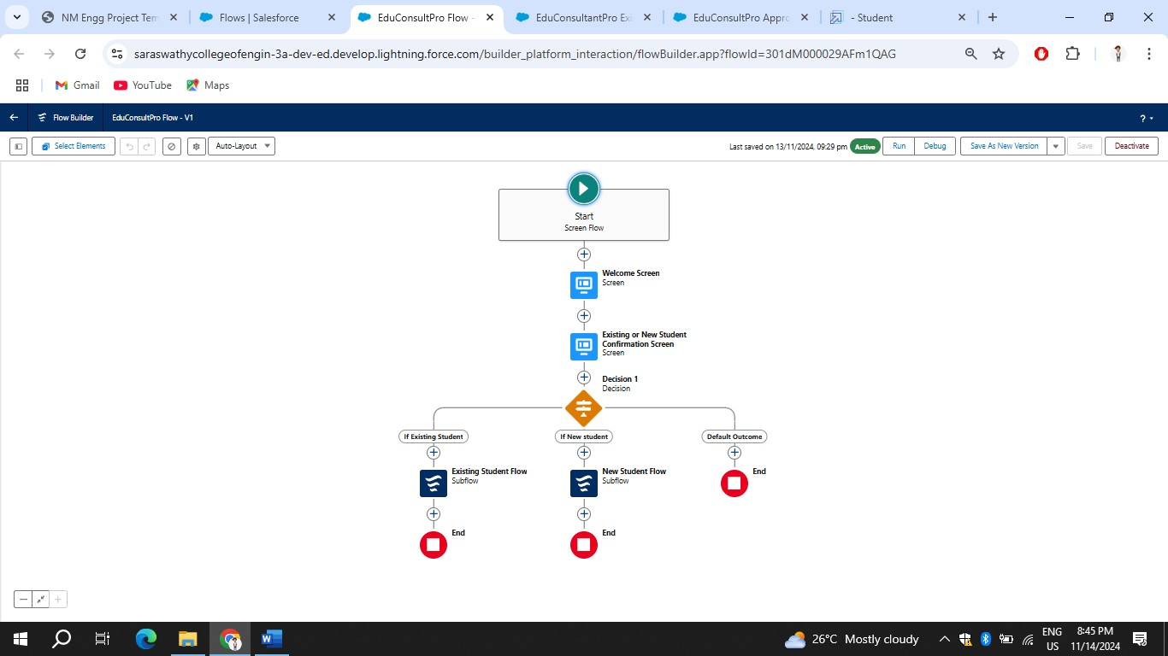

**Create a lightning app page**

## Create a lightning app page

1. From Setup, enter App Builder in the Quick Find box, then click Lightning App Builder.
2. Click New, select Home Page, then click Next.
3. Step through the wizard and name the page “EduConsultPro Home Page”, select the Standard Home Page template, and then click Done.
4. Drag the Flow component to the top-right region.
5. Search for the “EduConsultantPro Flow” and click Save.

6.Click Activate, Click App and Profile, then click Assign to Apps and Profiles.

7.Select the Sales app, then click Next.

8.Scroll down the list of profiles and select System Administrator, then click Next.

9.Review the assignment, and then click Save.

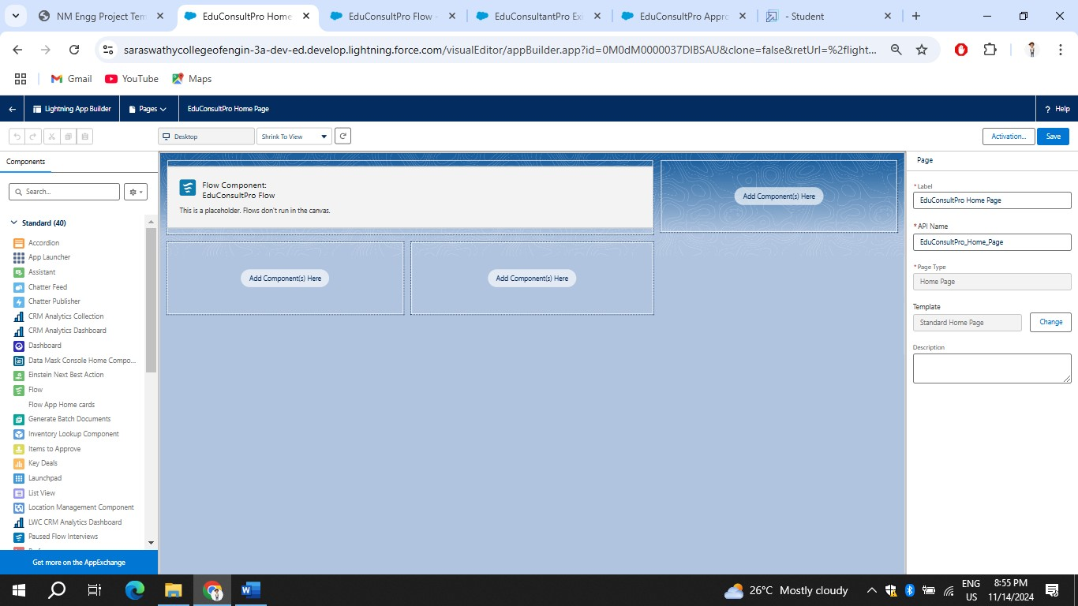

# Testing and Validation

We run the final flow of the project. The result is below:-

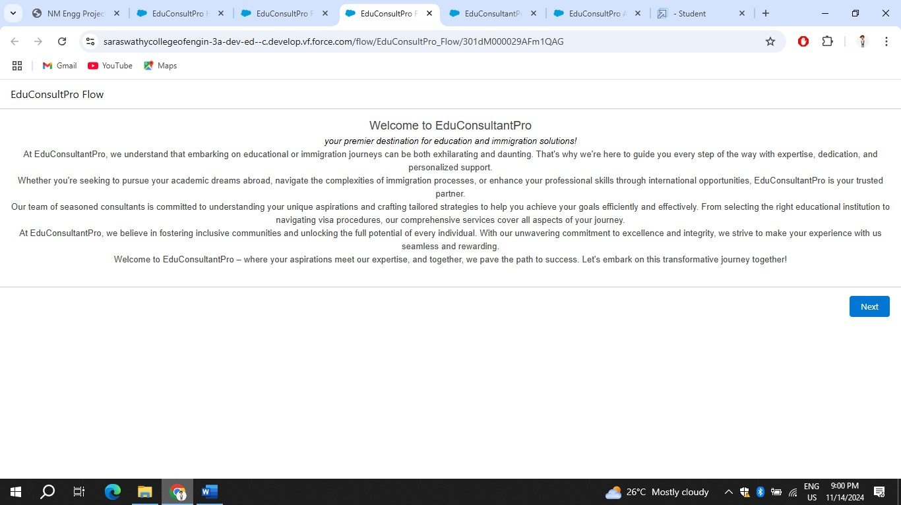

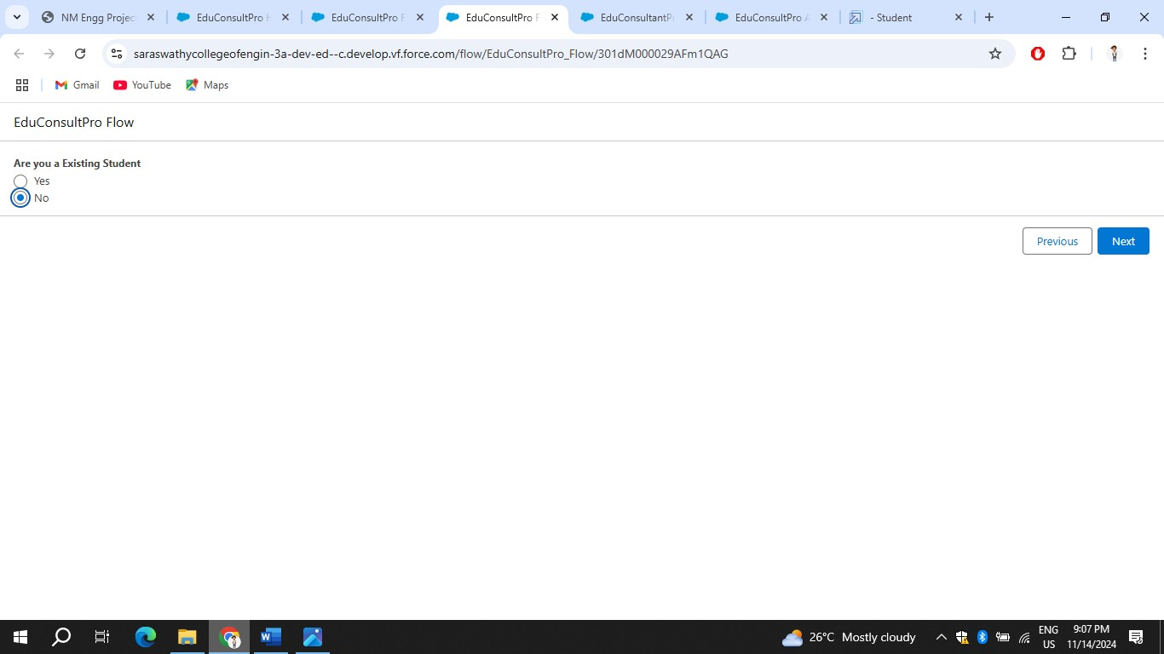

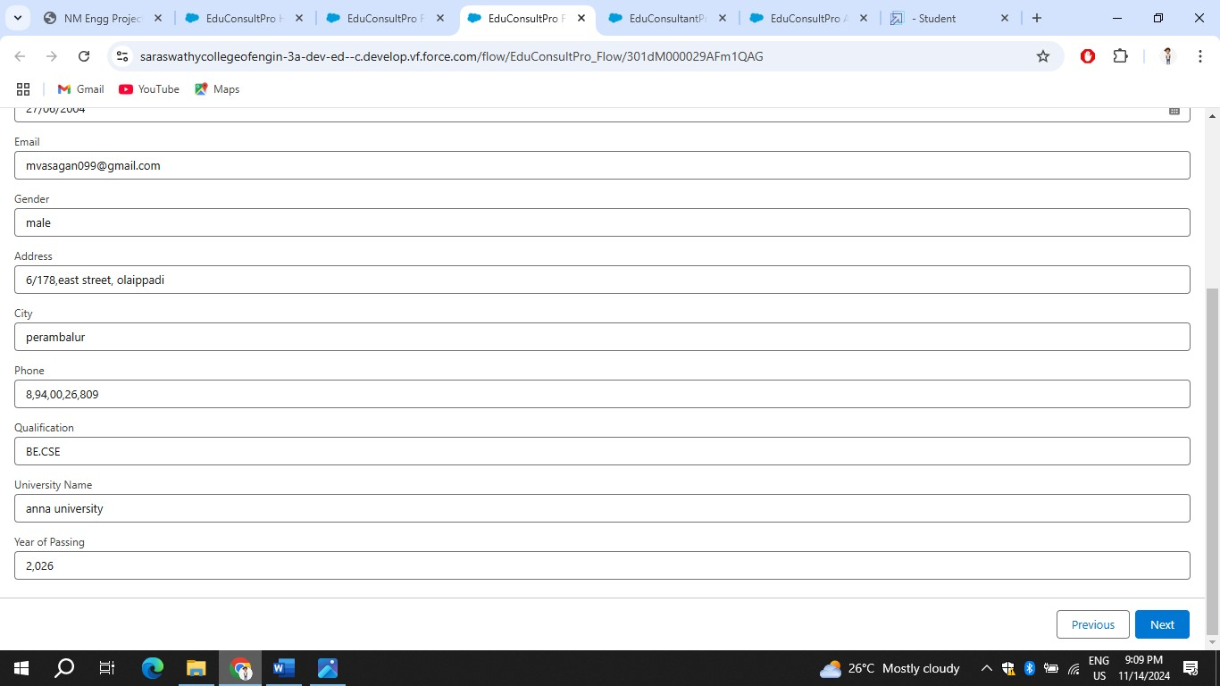

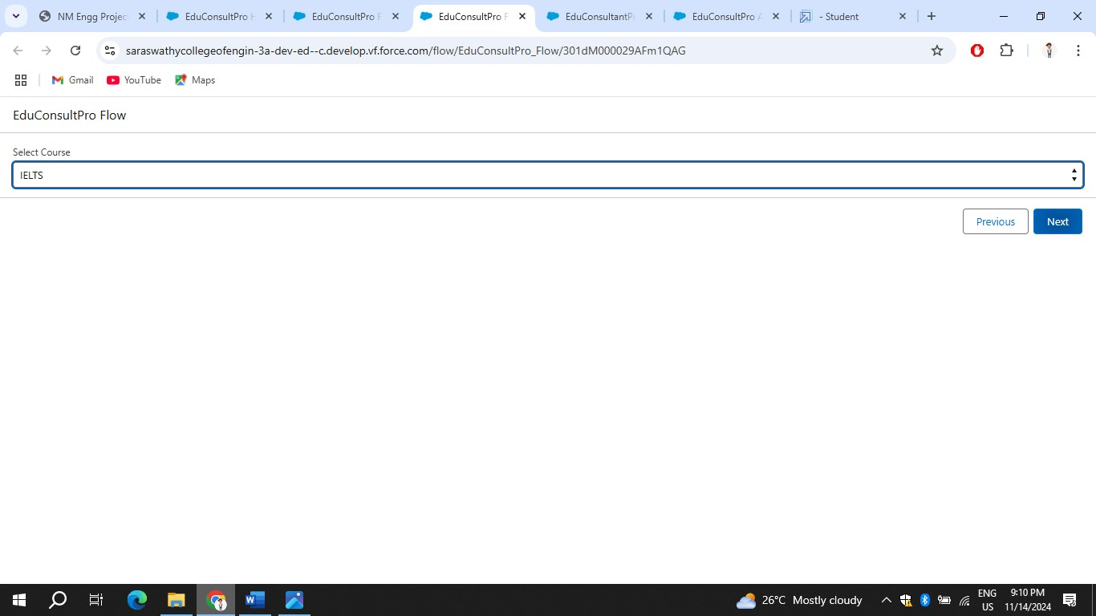

**Key Scenarios Addressed by Salesforce in the Implementation Project**

## 1. Data Migration and Integration

* **Scenario:** Migrating existing data from legacy systems (like ERP, CRM, spreadsheets) into Salesforce and ensuring smooth integration with thirdparty systems.
* **Solution:** Using tools like Data Loader, MuleSoft, or custom APIs to extract, transform, and load (ETL) data into Salesforce. Integration scenarios also address syncing data between Salesforce and other systems in real-time or batch mode.

2. Customization of Salesforce Objects and Fields • **Scenario:** Customizing Salesforce’s standard objects (like Accounts, Contacts, Opportunities) and adding custom objects, fields, and page layouts to meet specific business processes.

• **Solution:** Using Salesforce’s declarative tools such as custom fields, objects, record types, and page layouts. In more complex cases, custom development might be done via Apex code and Visualforce pages.

## 3. Automation of Business Processes

* **Scenario:** Automating workflows to streamline business processes such as lead management, approval processes, and case resolution.
* **Solution:** Implementing Salesforce automation tools such as Workflow Rules, Process Builder, Flow, and Apex triggers to automate business tasks, notifications, and approvals.

## 4. User Roles, Profiles, and Permissions

* **Scenario:** Defining user roles, profiles, and permissions to control data access, visibility, and security based on the organization’s structure.
* **Solution:** Creating role hierarchies, assigning users to profiles, and applying permission sets to ensure that users can access only the necessary data while maintaining appropriate security levels.

## 5. Mobile Access and User Experience

* **Scenario:** Ensuring the Salesforce platform is optimized for mobile access, so sales teams and service agents can access customer data on-the-go.
* **Solution:** Configuring Salesforce mobile app settings, designing mobilefriendly page layouts, and ensuring key data is accessible through the Salesforce mobile interface. Using Lightning Web Components for a responsive experience.

## 6. Reporting and Analytics

* **Scenario:** Designing and implementing reports and dashboards to provide real-time business insights, monitor performance, and make data-driven decisions.
* **Solution:** Configuring custom reports, dashboards, and lenses to meet business needs. Implementing features like dynamic dashboards and scheduled report deliveries.

## 7. Salesforce Lightning Migration

* **Scenario:** Migrating from Salesforce Classic to Salesforce Lightning, taking advantage of the modern UI and enhanced functionality.
* **Solution:** Analyzing the current Salesforce setup, identifying any custom features or components that need to be reworked, and transitioning to the Lightning Experience, which offers improved user interface, performance, and added features like Lightning components.

## 8. Customer Service and Case Management

* **Scenario:** Implementing Salesforce Service Cloud for managing customer support cases, service requests, and improving customer service efficiency.
* **Solution:** Configuring Service Cloud features like Case Management, Knowledge Base, and Service Console. Setting up escalation rules, automated workflows, and Omnichannel routing for a streamlined customer support experience.

## 9. Lead and Opportunity Management

* **Scenario:** Enhancing the lead and opportunity management process to track sales progress and optimize conversions.
* **Solution:** Customizing lead and opportunity stages, automating lead assignments, and using forecasting tools in Salesforce to help sales teams manage their pipelines and improve sales performance.

## 10. Security and Compliance

* **Scenario:** Ensuring that Salesforce complies with industry standards and regulations such as GDPR, HIPAA, or SOC 2.
* **Solution:** Implementing data encryption, field-level security, and audit trails. Configuring access controls, session settings, and data retention policies to meet regulatory and security requirements.

## 11. Collaboration and Chatter

* **Scenario:** Improving team collaboration within Salesforce by using Chatter for internal communication, sharing files, and collaborating on records.
* **Solution:** Enabling Chatter features, creating Chatter groups, and integrating collaboration into records and processes to improve communication across teams.

## 12. User Training and Change Management

* **Scenario:** Ensuring that all users are adequately trained to use Salesforce and can adapt to the new processes and system changes.
* **Solution:** Creating and executing a comprehensive change management plan that includes user training, knowledge base articles, and ongoing support.

Using Salesforce’s Trailhead platform for self-paced learning and adoption.

## 13. Custom Development for Advanced Features

* **Scenario:** Addressing complex business needs that cannot be met through standard Salesforce functionality.
* **Solution:** Developing custom applications, integrations, and components using Apex (for server-side logic), Visualforce (for custom UI), and Lightning Web Components (for modern, reusable web components).

## 14. Salesforce Communities

* **Scenario:** Implementing Salesforce Community Cloud to engage with partners, customers, or employees in a branded portal.
* **Solution:** Configuring and customizing Communities for self-service support, partner collaboration, or employee engagement. Ensuring proper access, branding, and content management.

## 15. Data Security and Backup Strategy

* **Scenario:** Ensuring that data within Salesforce is backed up, protected, and recoverable in case of a disaster.
* **Solution:** Implementing data backup strategies using third-party apps or Salesforce’s own backup solutions, along with role-based security policies and compliance measures.

**Conclusion:-**

Implementing a CRM (Customer Relationship Management) application to manage the services offered by an institution provides significant benefits in terms of streamlining operations, enhancing customer engagement, and improving overall service delivery. By centralizing information related to clients, services, and interactions, a CRM enables institutions to offer more personalized, responsive, and efficient services.